**INFORMATION TECHNOLOGY AND MANAGEMENT**

**ITMT 531**

**Fall 2015 – Data Analytics and Modelling Project**

1. Using the following relations and subordinate dependencies convert these relations into an NER diagram. (1) Draw the subordinate dependency graph, (2) “circle” RHMOs, (3) draw NER diagram, and (4) repeat these steps for each complex object at the next (more detailed) level of abstraction.
2. Convert your NER diagrams into one Object Model diagram

**CORP-INFO ( CORP-ID, CORP-NAME, PRES, TAX-ID)**

**DIVISIONS ( DIV#, CORP-ID, DIV-MGR# )**

**DIV-EMPLOYEES ( EMP#, DIV#, JOB-TITLE)**

**LOGISTIC-EMP ( EMP#, VEHICLE-RATING )**

**VEHICLE-FLEET ( VEHICLE-ID, WAREHOUSE-ID )**

**VEHICLE-ASGNMT ( DATE, EMP#, VEHICLE-ID, #-CUST)**

**WAREHOUSE-EMP ( EMP#, WAREHOUSE-ID )**

**WAREHOUSES (WAREHOUSE-ID, WAREHOUSE-SITE )**

**WAREHOUSE-ITEM-LOC ( WAREHOUSE-ID, ITEM-ID, AISLE#, BIN#, QNTY )**

**INV-ITEMS ( ITEM-ID, ITEM-DESCR, UNIT-PRICE )**

**CORP-EMP ( EMP#, CORP-ID )**

**PRODUCT-EMP ( EMP#, PRODUCT-AREA )**

**SALES-EMP ( EMP#, SALES-DISTRICT )**

**SUP-ORDERS ( SUP-ORDER#, DATE, SUPPLIER-ID )**

**SUP-ORDER-ITEMS ( SUP-ORDER#, ITEM-ID, QNTY-ORDERED,WAREHOUSE-ID )**

**SUPPLIER ( SUPPLIER-ID, SALES-CONTACT )**

**CUSTOMERS ( CUST-ID, CUST-SITE )**

**CUST-ORDERS ( CUST-ORDER#, CUST-ID, CORP-ID )**

**CUST-ORDER-ITEMS ( CUST-ORDER#, ITEM-ID, QNTY-ORDERED )**

**DIVISIONS.CORP-ID 🡪 CORP-INFO.CORP-ID**

**DIV-EMPLOYEES.DIV# 🡪 DIVISIONS.DIV#**

**LOGISTIC-EMP.EMP# 🡪 DIV-EMPLOYEES.EMP#**

**VEHICLE-FLEET.WAREHOUSE-ID 🡪 WAREHOUSES.WAREHOUSE-ID**

**VEHICLE-ASGNMT.EMP# 🡪 LOGISTIC-EMP.EMP#**

**VEHICLE-ASGNMT.VEHICLE-ID 🡪 VEHICLE-FLEET.VEHICLE-ID**

**CORP-EMP.CORP-ID 🡪 CORP-INFO.CORP-ID**

**SALES-EMP.EMP# 🡪 CORP-EMP.EMP#**

**PRODUCT-EMP.EMP# 🡪 CORP-EMP.EMP#**

**WAREHOUSE-EMP.EMP# 🡪 DIV-EMPLOYEES.EMP#**

**WAREHOUSE-EMP.WAREHOUSE-ID 🡪 WAREHOUSES.WAREHOUSE-ID**

**WAREHOUSE-ITEM-LOC.ITEM-ID 🡪 INV-ITEMS.ITEM-ID**

**WAREHOUSE-ITEM-LOC.WAREHOUSE-ID 🡪 WAREHOUSES.WAREHOUSE-ID**

**SUP-ORDER#.SUPPLIER-ID 🡪 SUPPLIER.SUPPLIER-ID**

**SUP-ORDER-ITEMS.SUP-ORDER# 🡪 SUP-ORDERS.SUP-ORDER#**

**SUP-ORDER-ITEMS.ITEM-ID 🡪 INV-ITEMS.ITEM-ID**

**SUP-ORDER-ITEMS.WAREHOUSE-ID 🡪 WAREHOUSES.WAREHOUSE-ID**

**CUST-ORDERS.CUST-ID 🡪 CUSTOMERS.CUST-ID**

**CUST-ORDERS.CORP-ID 🡪 CORP-INFO.CORP-ID**

**CUST-ORDER-ITEMS.CUST-ORDER# 🡪 CUST-ORDERS.CUST-ORDER#**

**CUST-ORDER-ITEMS.ITEM-ID 🡪 INV-ITEMS.ITEM-ID**

**Answer 1:**

The Subordinate Dependency diagram is as follows:

1.

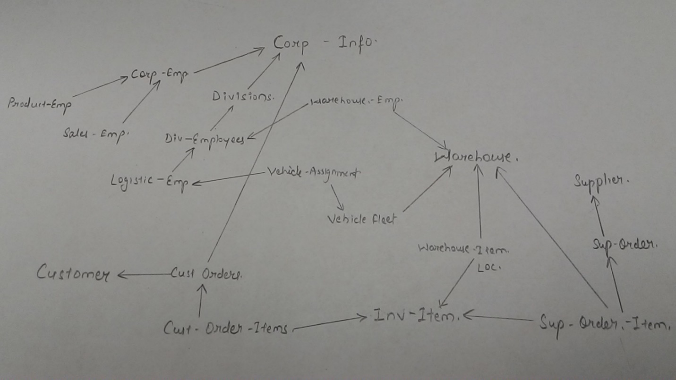

1. Circle RHMOs:

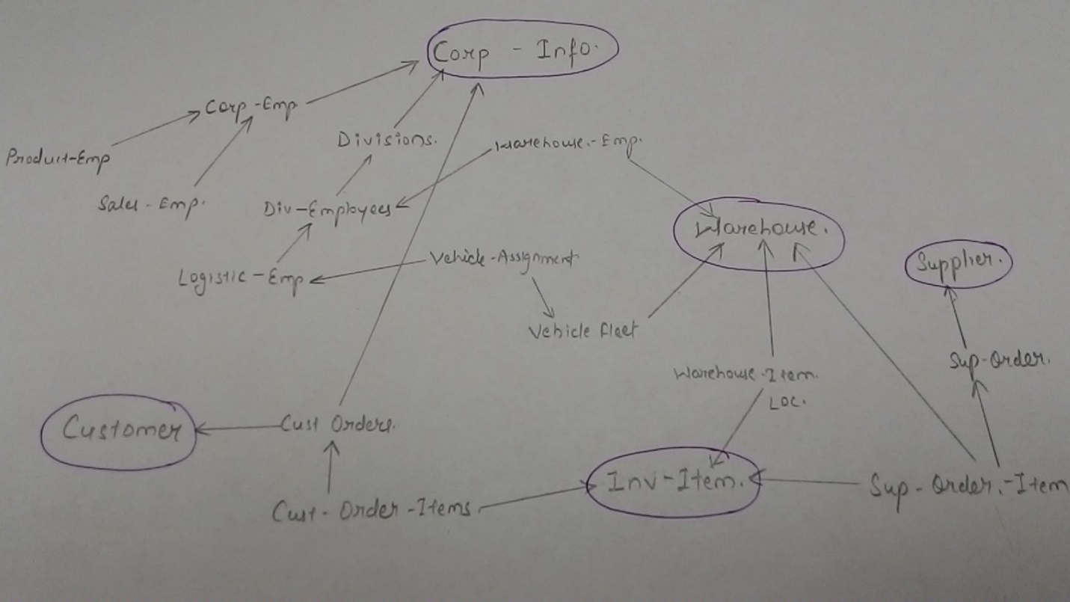

3.

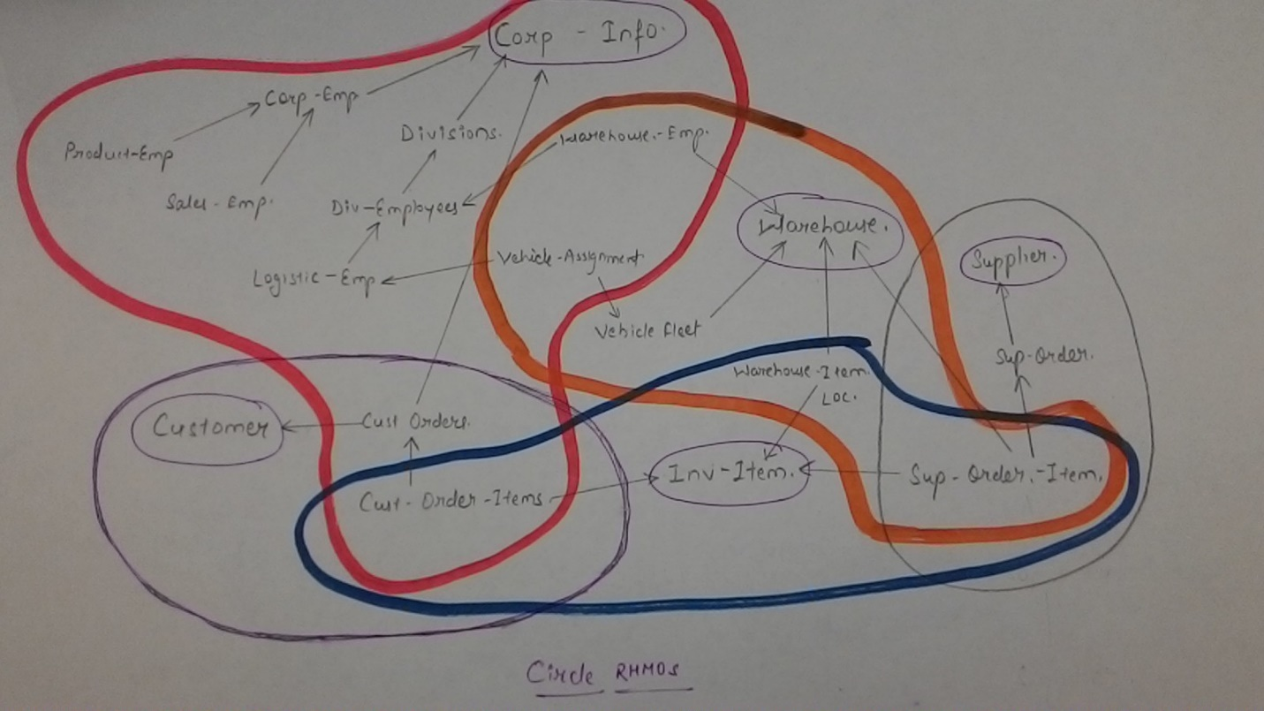

1. Resultant NER Diagram

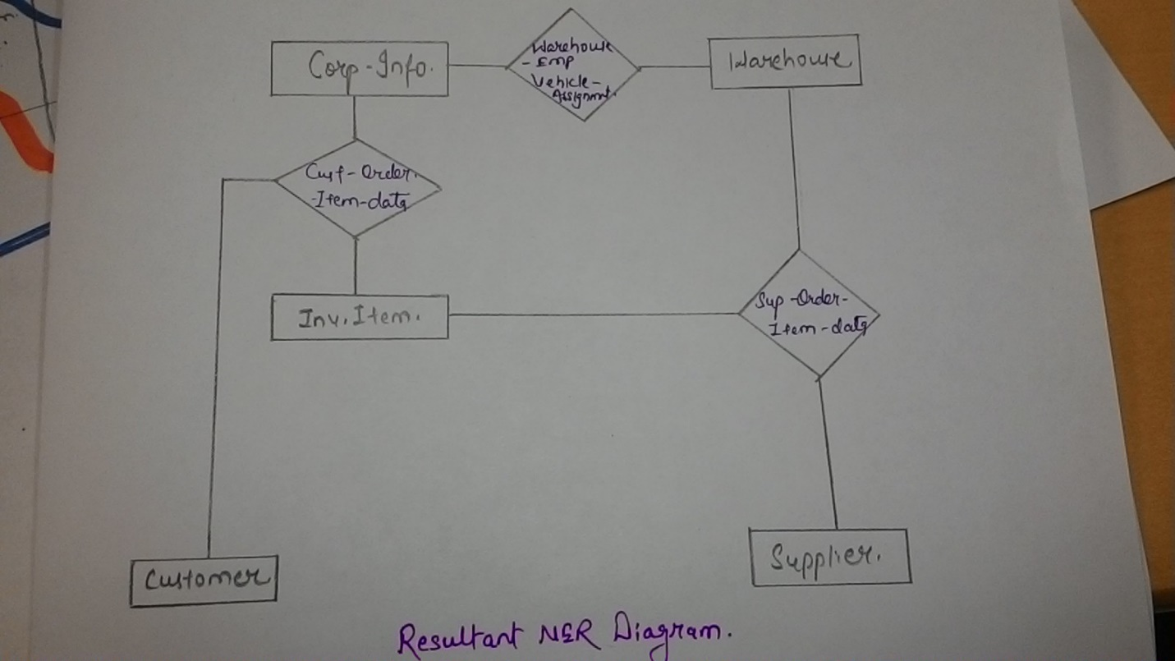

1. Association:

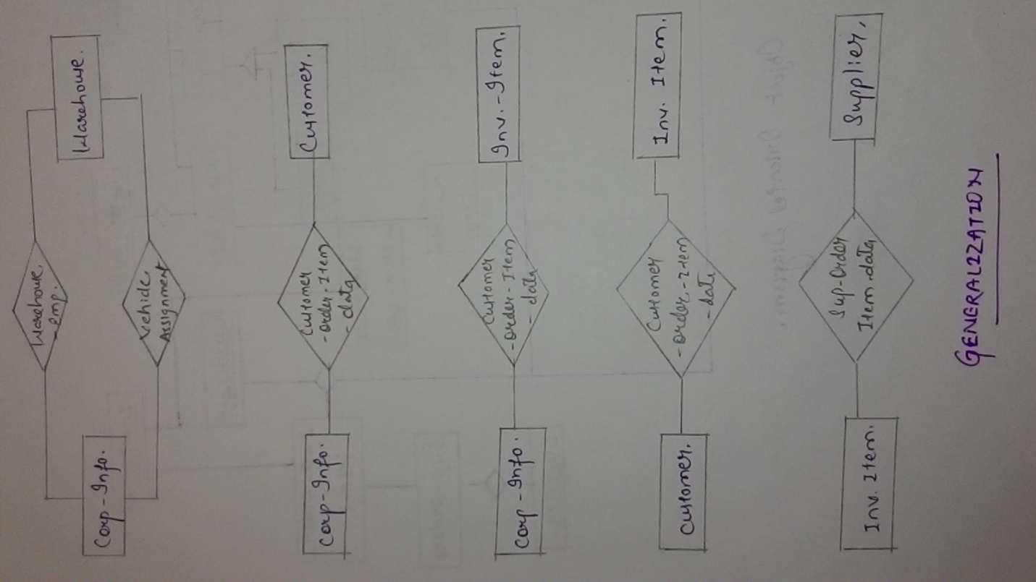

6.

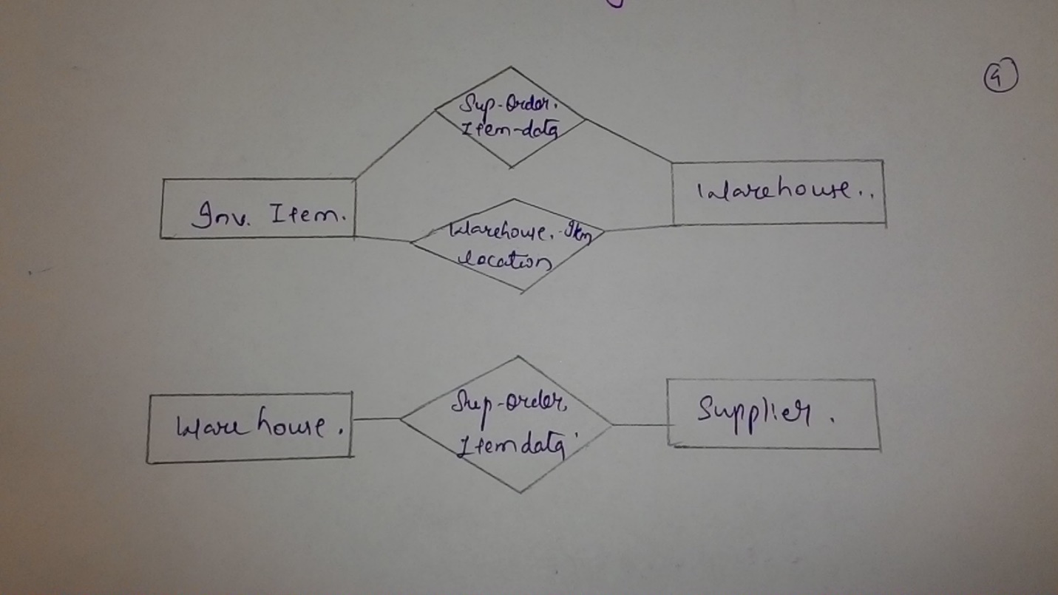

7.

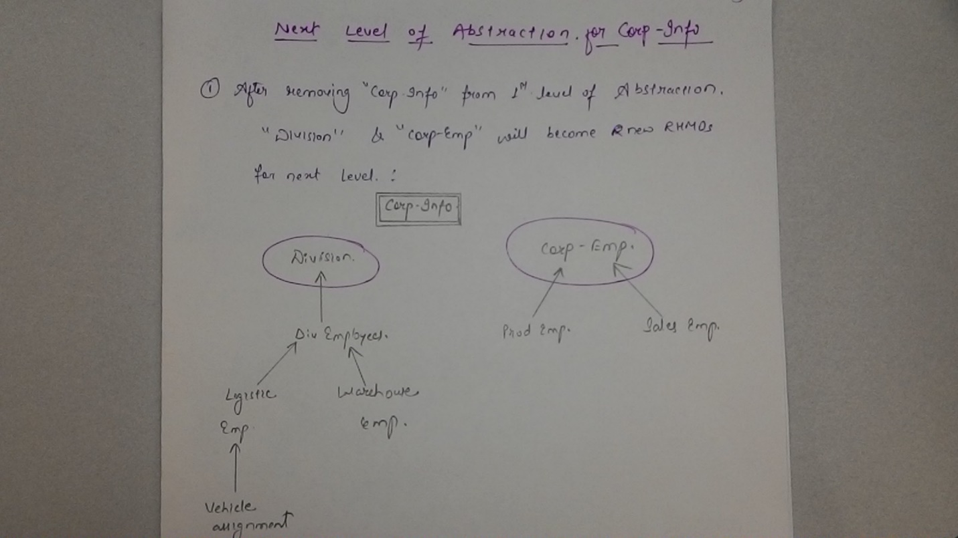

8.

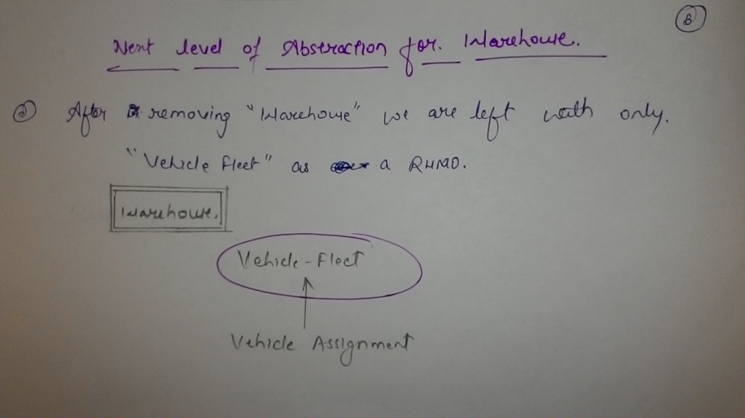

9.

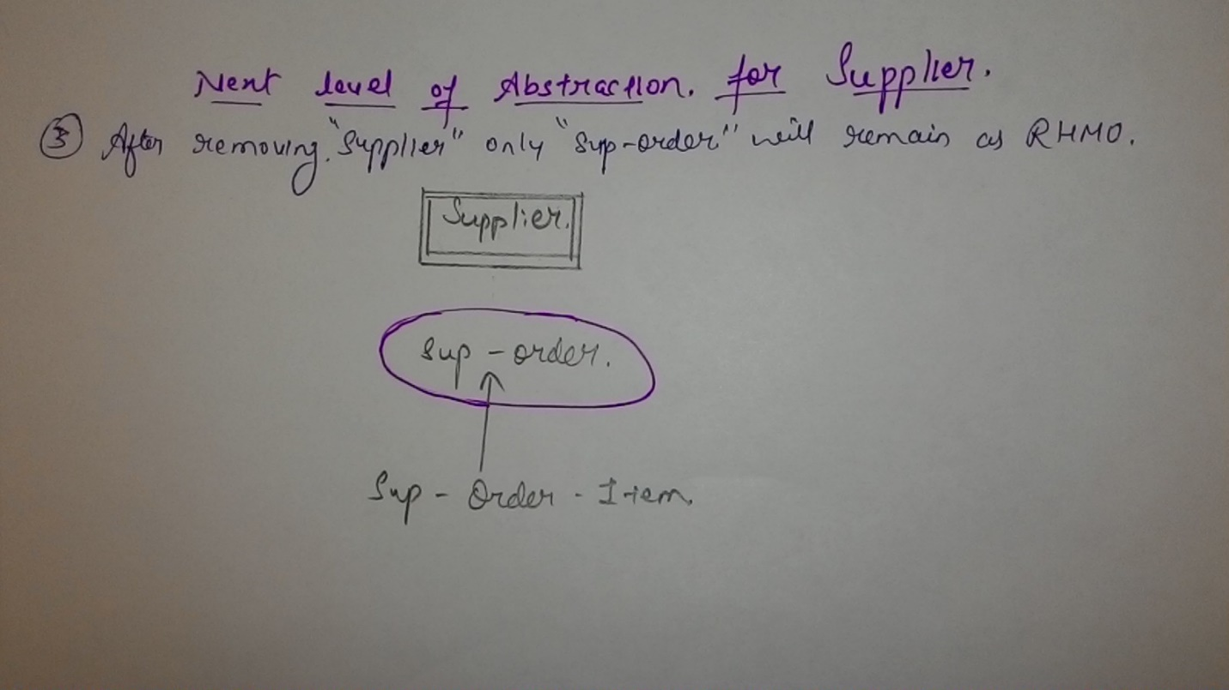

Answer 2: Object Oriented Diagram:

